Predicting FIFA Player Ratings Using Regression Models: A Comprehensive Analysis of Key Attributes and Predictive Accuracy
Author: Raja Prabakaran
Background, Motivation, and Significance
- Background: FIFA player ratings are a critical benchmark for assessing player performance and potential. They are used by scouts, managers, and analysts to make key decisions in player development, transfers, and strategy.
- Significance:
  - Provides actionable insights into which attributes most influence a player's overall rating.
  - Demonstrates how statistical models can improve understanding and decision-making in sports analytics.
- Motivation:
  - Explore how attributes like dribbling, passing, and physical ability impact FIFA ratings.
  - Identify the best predictive model (linear vs. polynomial regression, Ridge, and Lasso) to bridge the gap between data analysis and practical applications.
Research Questions
- What attributes most influence FIFA player ratings?
  - Examining the role of key player skills such as dribbling, passing, and physicality.
- How accurately can regression models predict FIFA player ratings?
  - Testing both linear and non-linear regression approaches for predictive effectiveness.
- Which regression model performs best in terms of accuracy and validation?
  - Comparing performance metrics like R², MSE, and RMSE across linear, polynomial, and regularized models.
Data Set Description
- Sample Size: The dataset consists of 16,210 records, representing professional FIFA players.
- Variables Used:
  - Response Variable: overall (player rating).
  - Predictor Variables: wage_eur, age, value_eur, pace, shooting, passing, dribbling, defending, physic, skill_moves, and weak_foot.
- Handling Missing Values:
  - Rows with missing values were removed during preprocessing.
  - Total missing values after cleaning: 0.
Pre-Processing
- Data Selection:
  - The analysis focuses on the overall rating as the response variable.
  - Key predictors include wage_eur, age, value_eur, pace, shooting, passing, dribbling, defending, physic, skill_moves, and weak_foot.
- Handling Missing Data:
  - Rows with missing values were removed to ensure a complete dataset for analysis.
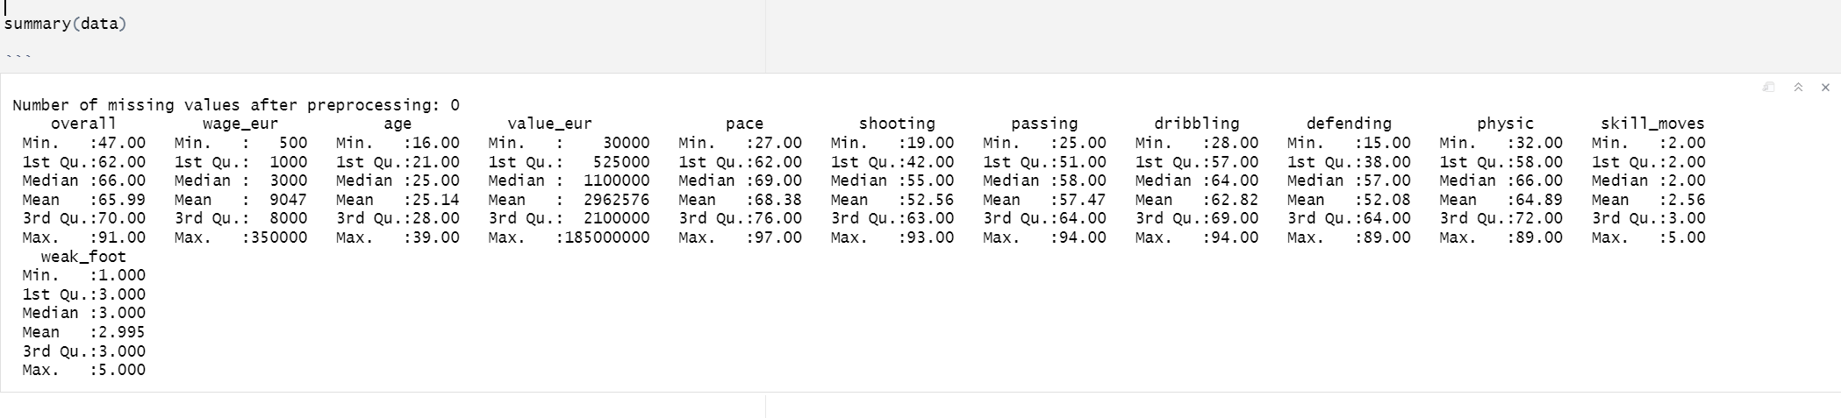
  - After cleaning, no missing values remained, resulting in a dataset ready for analysis.

- Multicollinearity Assessment:
  - Variance Inflation Factors (VIF) were computed to evaluate multicollinearity among predictors.
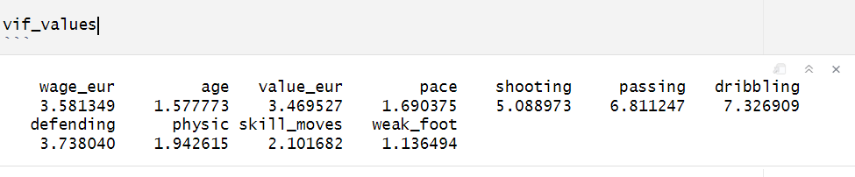
  - All VIF values were below the threshold of 10, indicating no significant multicollinearity issues. Thus, all predictors were retained in the model.

Exploratory Data Analysis (EDA)
- Distribution Analysis:
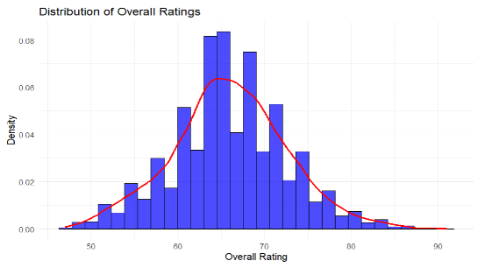
  - The histogram of overall ratings shows a roughly normal distribution centered around 65–70.
- Correlation Analysis:
  - A correlation matrix was generated to identify relationships between predictors and the target variable (overall).
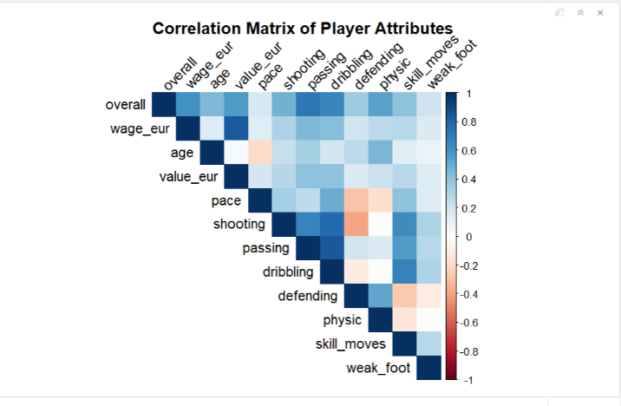
  - Attributes such as passing, dribbling, and shooting show the strongest correlations with the target variable (overall), while weak_foot and skill_moves have limited impact. This indicates the importance of technical skills in determining player ratings
Methodology
- Linear Regression:
  - Purpose: Acts as a baseline model to understand the relationships between predictors and the response variable (overall rating).
  - Process:
    - A multiple linear regression model was fitted using all predictors (wage_eur, age, value_eur, pace, shooting, passing, dribbling, defending, physic, skill_moves, weak_foot).
  - Results:
    - Adjusted R^2: 0.8018
    - MSE: 8.9158
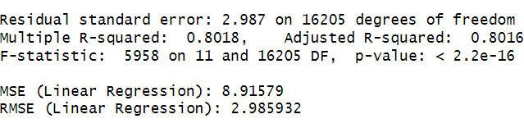
    - RMSE: 2.9859
  - Conclusion:
    - Linear regression performed reasonably but failed to capture complex relationships due to its simplicity.
- Polynomial Regression:
  - Purpose: To capture non-linear relationships between predictors and the response variable.
  - Process:
    - Added squared terms for key predictors to the dataset to account for quadratic effects.
    - The polynomial regression model was fitted with these additional terms, and the performance metrics were calculated.
  - Results:
    - Adjusted R^2: 0.8883
    - MSE: 5.0176
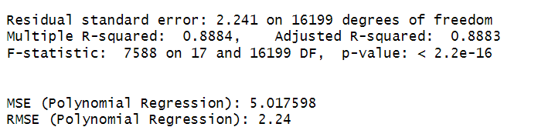
    - RMSE: 2.2401
  - Conclusion:
    - Polynomial regression showed significant improvement over Linear Regression, suggesting the presence of non-linear relationships in the data.
- Ridge Regression:
  - Purpose: To address multicollinearity and prevent overfitting by applying regularization.
  - Process:
    - Applied Ridge regression with cross-validation to determine the optimal regularization parameter (λ).
  - Results:
    - Best λ: 0.4857
    - MSE: 7.9558
    - RMSE: 2.8206
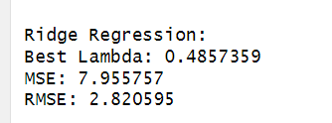
  - Conclusion:
    - While Ridge regression improved multicollinearity but did not outperform Polynomial Regression.
- Lasso Regression:
  - Purpose: To perform feature selection by shrinking insignificant predictors to zero.
  - Process:
    - Lasso regression was applied with cross-validation to determine the optimal λ.
    - Predictors were standardized before fitting the model.
  - Results:
    - Best λ: 0.0004
    - MSE: 5.0230
    - RMSE: 2.2412
    - Some predictors (e.g., weak_foot) were eliminated due to their negligible contributions.
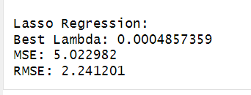
  - Conclusion:
    - Lasso regression provided comparable performance to Polynomial Regression and improved model interpretability but had slightly higher MSE.

Based on Adjusted R^2, MSE, and RMSE, Polynomial Regression is identified as the best model.

- Cross-Validation for the Best Model:
- Purpose: To validate the robustness and generalizability of Polynomial Regression.
- Process:
  - Performed 10-fold cross-validation on Polynomial Regression (best fit).
- Results:
  - Mean MSE: 5.0359
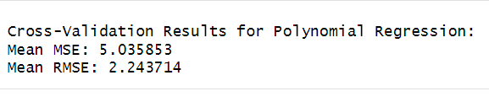
  - Mean RMSE: 2.2437
- Conclusion:
  - Cross-validation confirms that Polynomial Regression generalizes well to unseen data.
- Residual Analysis:
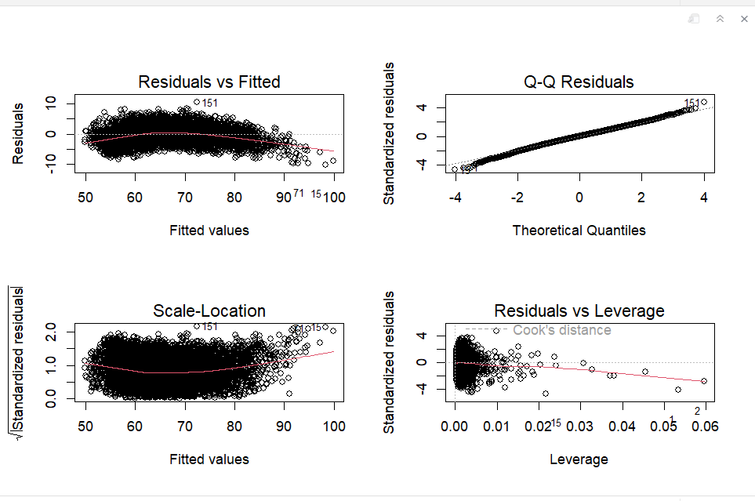
Residual Diagnostics
      - The Residuals vs Fitted plot shows residuals are randomly scattered around the horizontal axis, suggesting that the model appropriately captures the relationships in the data.
      - The Q-Q plot demonstrates that residuals are mostly aligned with theoretical quantiles, indicating approximate normality with minor deviations at the extremes.
      - The Scale-Location plot shows a relatively consistent spread, confirming homoscedasticity.
      - The Residuals vs Leverage plot identifies potential influential points. Observations beyond Cook's distance threshold were further examined and removed to refine the model.

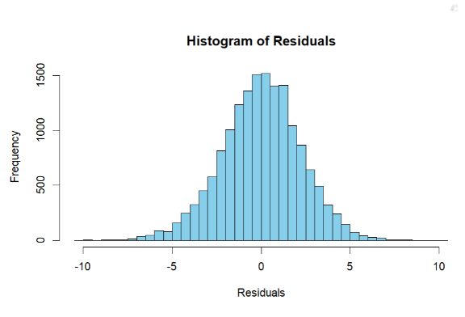
Histogram of Residuals
      - The histogram of residuals depicts a roughly normal distribution centered around zero, validating the assumption of normally distributed residuals.
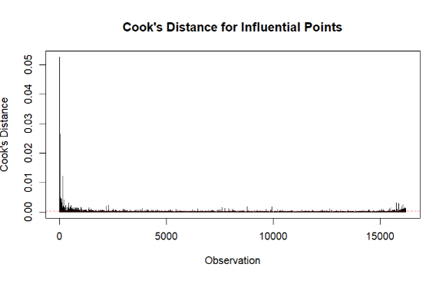
Cook’s Distance for Influential Points
      - The Cook’s distance plot highlights observations with high leverage that could influence the model. Points exceeding the threshold were removed from the dataset. After excluding these high-leverage points, the model's performance improved significantly.

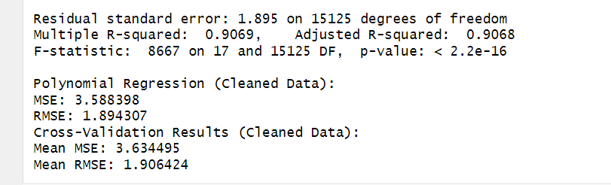
- Polynomial Regression with Cleaned Data Based on Cook’s Distance

      - After removing high-leverage points, the refined polynomial regression model demonstrated the following improvements:
        - Mean Squared Error (MSE): Reduced to 3.588398 (from 5.017598 before cleaning).
        - Root Mean Squared Error (RMSE): Reduced to 1.894307 (from 2.241201 before cleaning).
        - Cross-Validation Results:
          - Mean MSE: 3.634495.
          - Mean RMSE: 1.906424.
      - The adjusted R² increased to 0.9068, indicating that the model now explains more variance in the response variable.
      - The quadratic terms (e.g., I(pace^2), I(shooting^2), I(passing^2)) were confirmed to have significant contributions to the overall model.

Results

Comparison of Model Performance Metrics
Method | Adjusted R² | MSE | RMSE | Cross-Validated RMSE
Linear Regression | 0.8016 | 8.9158 | 2.9859 | -
Polynomial Regression | 0.8883 | 5.0176 | 2.2401 | 2.2437
Ridge Regression | - | 7.9558 | 2.8206 | -
Lasso Regression | - | 5.0230 | 2.2412 | -
Polynomial (Cleaned) | 0.9068 | 3.5884 | 1.8943 | 1.9064

Polynomial Regression (Cleaned Data based on Cook’s Distance) emerged as the best-performing
Model:
- Highest Adjusted R² (0.9068) and lowest MSE (3.5884) and RMSE (1.8943).
- Cross-validation confirmed robustness, with a Cross-Validated RMSE of 1.9064.

Linear Regression served as a baseline model but showed weaker performance due to limited capture of non-linear relationships.

Ridge and Lasso Regression mitigated multicollinearity but underperformed compared to Polynomial Regression.

Conclusion

The Polynomial Regression model, refined by removing high-leverage points, emerged as the most effective approach for predicting FIFA player ratings. With its high Adjusted R² (0.9068) and low RMSE (1.8943), this model successfully captured the non-linear relationships between player attributes and their ratings. The inclusion of quadratic terms, such as pace², shooting², and passing², highlights the importance of these predictors in identifying peak potential. This methodology provides valuable insights for talent assessment, enabling teams to evaluate player potential and monitor performance growth.

